Advantage through virtual parts run-in

Virtual run-in on the digital twin yields enormous productivity gains: HANOMAG Aluminium Solutions GmbH refines aluminum components for the automotive industry through heat treatment and mechanical processing in Kassel and Baunatal, Germany. The d.u.h.Group used Siemens Xcelerator software to create the complete digital twin of the machinery. This enabled HANOMAG Aluminium Solutions to create and optimize NC programs on the computer model in parallel with production, reducing machine downtime during part run-in by 90 percent.

HANOMAG Aluminium Solutions GmbH is part of the Hanomag Lohnhärterei Group with production sites in Kassel and Baunatal, Germany, There, the company refines aluminum components for the automotive industry through heat treatment and mechanical processing on an impressive machine park with almost 40 4-axis and 5-axis CNC machining centers equipped with modern SINUMERIK controls. The processing intensity of the parts varies; the parts have processing times of between 75 and 540 seconds, their average production period is around seven years.

Parts run-up is a productivity factor
Until recently, machine programs were created and optimized directly on the machines. Running in each new component blocked the respective machine and operator for 15 shifts or five days. In order to carry out these activities as much as possible during normal working hours, Dominik Köhler, Production Manager Kassel at HANOMAG Aluminium Solutions, initiated a major digitalization step.

Programming while machining
To this end, the company was equipped with NX CAM software out of the Xcelerator portfolio fom Siemens Digital Industries Software. d.u.h.Group GmbH, a Platinum Smart Expert Partner of Siemens Digital Industries Software, created a customized solution for the implementation of the customer project. The manufacturing software specialists developed configurable post-processors for use with NX CAM that cover HANOMAG Aluminium Solutions’ entire machine park. This enables program creation in parallel with production time based on 3D part data.

To enable carrying out the run-in process in parallel with main production time in the office, the d.u.h.Group’s digitization experts created a complete digital twin of the machine tools. They took the opportunity to add the Siemens Virtual NC Controller Kernel (VNCK) to NX CAM. This allows machining simulation to be performed based on the real control software. This enables a realistic digital representation of the movements of the actual machine tools with the exact speeds, accelerations, tool changes, and cycle times. Programming, checking, and optimization of the complex machining processes now take place at computer workstations instead of at the machines. It is also possible to simulate manually generated NC code and provide direct feedback to the part design.

Substantial productivity gains
NX CAM simulation based on the digital twin of the entire machine park has revolutionized the run-in process for new parts at HANOMAG Aluminium Solutions. Parallel start-up on the computer model during production time helps prevent collisions, reduce risk, and avoid scrap. Although final optimizations continue to be carried out directly on the machine, downtime has been reduced from 15 shifts to just one.

"The savings amount to over 90 percent, or around 11,000 euros per component," emphasizes Dominik Köhler. "This alone means that the investment has paid for itself within a year."

Image captions:

HANOMAG Aluminium Solutions GmbH refines aluminum components primarily for the automotive industry through heat treatment and mechanical processing. To avoid blocking machines and personnel when running in new parts, the company switched to creating and optimizing machine programs during production time.  Photo: P. Kemptner | 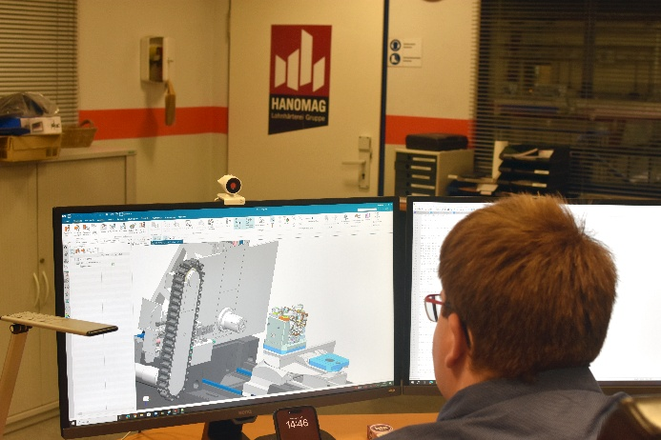
The d.u.h.Group’s digitalization experts implemented NX CAM, created configurable postprocessors, and used the Siemens Virtual NC Controller kernel to create a complete digital twin of the machine tools. The run-in process for new parts now takes place almost entirely on the computer model. It has reduced the time required directly on the machine from 15 shifts to just one. | 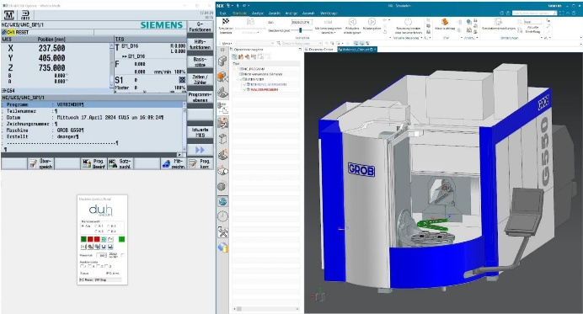
Dominik Köhler, Production Manager Kassel, HANOMAG Aluminum Solutions GmbH:  "Thanks to the largely parallel run-in of new components during production, the investment in Siemens NX CAM and the digital twin of our machine park based on VNCK paid for itself in less than a year." | 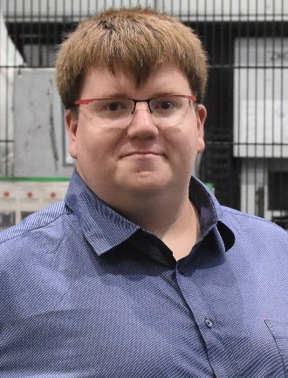

About d.u.h.Group:
Founded in 2012, d.u.h.Group GmbH is a medium-sized company headquartered in Bielefeld, Germany, with additional locations in Germany, Austria, and India. A long-standing Platinum Smart Expert Partner of Siemens Digital Industries Software, d.u.h.Group offers its customers tailor-made solutions to streamline their processes and drive their digital transformation. With the combined expertise of its predecessor companies CAE, Conmatix, and Nexeo, d.u.h.Group offers PLM solutions as well as consulting, training, and services in the areas of design, product development, simulation, NVH technologies, and measurement technology.

